,

GENERAL EDUCATION AND TRAINING CERTIFICATE

ABET LEVEL 4

MID-YEAR EXAMINATION

MARKING GUIDE

LEARNING AREA | : | MATHEMATICAL LITERACY
CODE | : | MLMS4
DATE | : | JUNE 2018
TIME | : | 3 HOURS
MARKS | : | 100

This memorandum consists of 6 pages.

Symbol | Explanation
M | Method
CA | Consistent accuracy
A | Accuracy
C | Conversion
S | Simplification
RT/RG | Reading from a table / Reading from a graph
F | Choosing correct formula
SF | Substitution in formula
J | Justification
P | Penalty, e.g. for no units, incorrect rounding off etc.
R | Rounding off / reason

QUESTION 1 |  | [27]

1.1.1 | $$318$$ | 1A Answer | (1)

1.1.2 | $$6,09$$ | 1A Answer | (1)

1.1.3 | $$\frac{26}{6}-\frac{14}{12}+\frac{9}{4}$$  $$=\frac{52-14+27}{12}$$  $$=\frac{65}{12}$$  $$=5\frac{5}{12}$$ | or | $$\left(4-1+2\right)+\left(\frac{2}{6}-\frac{2}{12}+\frac{1}{4}\right)$$  $$=5+\frac{2×2}{6×2}-\frac{2}{12}+\frac{1×3}{4×3}$$  $$=5+\frac{4}{12}-\frac{2}{12}+\frac{3}{12}$$  $$=5\frac{5}{12}$$ | 1 C Improper fraction/Multiples  1 S LCD/LCM  1 CA Answer | (3)

 | 1.1.4 | $$3,1 + 2,4 ×\frac{2}{1}$$  $$=3,1+4,8$$  $$=7,9$$ | 1 M Multiplicative inverse  1 A Answer | (2)

 | 1.1.5 | $$=14-6$$  $$=8$$ | 1 S Simplify roots  1 A Answer | (2)

 | 1.1.6 | $$=2401×216$$  $$=518 616$$ | 1 S Squaring  1 A Answer | (2)

 | 1.1.7 | $$=\frac{30}{100}×R250$$  $$=R75$$ | 1 M Calculation  1 A Answer | (2)

1.2 | 37 out of 50 is bigger | 1 A Answer | (1)

1.3 | $$1000+500+80+9$$ | 1 A Answer | (1)

1.4 | $$0,75 ;60\% ;\frac{1}{2}$$ | 3 $×$ 1 A per correct position | (3)

1.5 | $$1\frac{21}{100}$$ | 1 C Answer | (1)

1.6 | $$\frac{51}{100}$$ | 1 A Answer | (1)

 | 1.7.1 | $$R315,70$$ | 1 A Answer | (1)

 | 1.7.2 | $$55+53,90=118,90$$  $$\frac{10}{100}×118,90=11,89$$  $$118,90-11,89=R107,01$$ | 1 A Addition  1 C Percentage  1 CA Answer | (3)

1.8 | $$4$$ | 1 A Answer | (1)

1.9 | B. Pentagon | 1 A Answer | (1)

1.10 | $$\frac{2}{6}=\frac{1}{3}$$ | 1 A Answer | (1)

QUESTION 2 |  | [19]

2.1 | 2.1.1 | 1 : 2 | 1 A Answer | (1)

 | 2.1.2 | 28 days : 21 days  = 4 : 3 | or | 4 weeks: 3weeks  = 4 : 3 | 1 C Concersion  1 A Answer | (2)

2.2 | 2.2.1 | 05 hours 45 minutes or  05,75 hours | 1 A Answer | (1)

 | 2.2.2 | 5 hours | 1 A Answer | (1)

 | 2.2.3 | $$\frac{459 km}{5 h}$$  $$=91,8 km /h$$ | 1 SF Substitution  1 CA Answer | (2)

 | 2.2.4 | $$\frac{459 km}{100 km}×8l$$  $=36,72 l$ or |  | 1 M Calculation  1 A Answer | (2)
   | { | $$100km$$ | $$:$$ | $$8 l$$ | }
  $$÷100$$ | { |  |  |  | } | $$÷100$$
   | { | $$1km$$ | $$:$$ | $$0,08 l$$ | }
   | { |  |  |  | }
  $$×459$$ | { |  |  |  | } | $$×459$$
   | { | $$459km$$ | $$:$$ | $$36,72l$$ | }

 | 2.2.5 | Petrol cost $=R13,05×36,72$  = $R479,20$  Total $=R479,20+R168+R114,90$  $$=R762,10$$ | 1 CA Price by litres  1 CA Addition  1CA Answer | (3)

 |  | 2.2.6 | - Use social media to spread the message  - Partner with many other organisation e.g SAPS  Any other relevant answer | 1 J Answer | (1)
 |  | 2.3.1 | North East | 1 A Answer | (1)

 | 2.3.2 | Emalahleni | 1 A Answer | (1)

 | 2.3.3 | North | 1 A Answer | (1)

 | 2.3.4 | - D4  - D1 | 1 A Answer  1 A Answer | (2)

 | 2.3.5 | Mokopane | 1 A Answer | (1)

QUESTION 3 |  | [27]

 | 3.1.1 | 55 years | 1 A Answer | (1)

 | 3.1.2 | Mean = $\frac{763}{20}$  38,15 years | 1 M Calculation  1 A Answer | (2)

 | 3.1.3 |  | 1 A Stem  1 A All leaves correct  1 A leaves in order | (3)
  Stem | Leaves
  1 | 6 | 7
  2 | 4 | 5 | 5 | 6 | 7
  3 | 5 | 6 | 7
  4 | 2 | 3 | 5 | 8 | 9
  5 | 0 | 3 | 5 | 5 | 5

 | 3.1.4 | $$\frac{37+42}{2}$$  39,5 years | 1 M Calculation  1 A Answer | (2)

 | 3.1.5 | 55 years | 1 A Answer | (1)

 | 3.1.6 | $$55-16$$  = 39 years | 1 M Subtraction  1 A Answer | (2)

 | 3.1.7 | - Teenage pregnancy forced her out of school.  - Lost a number of years and fell behind peers  Any other relevant answer | 1 J Answer | (1)

 | 3.2.1 |  | 4 $×$1 A Correct Tally & Frequency together  Penalise:Correct Freq Only  Penalise:Correct Tally Only | (4)
  Colour | Tally | Frequency
  Red | / / / / | 5
  Green | / / / / / / / | 8
  Purple | / / / / | 4
  Orange | / / | 2
  Pink | / | 1

 | 3.2.2
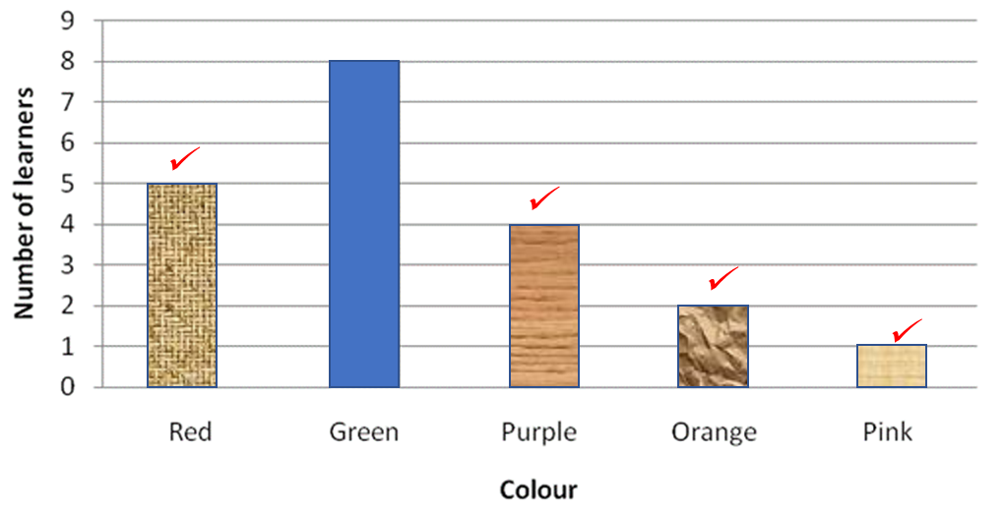 |  |  | 4 $×$ 1 CA Correct Bar according to Frequency in 3.2.1 | (4)

 | 3.2.3 | Green | 1 A Answer | (1)

3.3 | 3.3.1 | 11 marbles | 1 A Answer | (1)

 | 3.3.2 | P(red) $=\frac{4}{16} =\frac{1}{4}$ | 1 A Answer  1 A Simplification | (2)

 | 3.3.3 | P(green) $=\frac{5}{16}$ | 1 A Answer | (1)

 | 3.3.4 | P(blue and red) $=\frac{0}{16}=0$or None | 2 A Answer | (2)

QUESTION 4 |  | [16]

 | 4.1.1 | Circle | 1 A Answer | (1)

 | 4.1.2 | Hexagon | 1 A Answer | (1)

 | 4.1.3 | Rectangular Prism | 1 A Answer | (1)

 | 4.1.4 | Triangular Prism | 1 A Answer | (1)

 | 4.1.5 | Cylinder | 1 A Answer | (1)

4.2 | 4.2.1 | Radius = $6,5 m$ | 1 A Answer | (1)

 | 4.2.2 | Perimeter $=3.14×13m$  $$=40,82 cm$$ | 1 SF Calculation  1 A Answer | (2)

 | 4.2.3 | Area$=3,14×{\left(6,5 m\right)}^{2}$  $$=132,67 m^{2}$$ | 1 SF Calculation  1 A Answer | (2)

4.3 | $$700 cm=7 m$$  TSA $=2\left[\left(7 m×3m\right)+\left(7m×5m\right)+\left(3m×5m\right)\right]$  $$=142 m^{2}$$ | 1 C Conversion  1 SF Calculation  1 CA Answer | (3)

4.4 | $$Volume=\frac{1}{2}× 8cm × 3cm ×12cm$$  $$=144 cm^{3}$$ | 1 SF Calculation  1 A Answer  1 A Units | (3)

QUESTION 5 |  | [11]

5.1 | $$AB^{2}={\left(3m\right)}^{2}+{\left(4m\right)}^{2}$$  $$=9m^{2}+16m^{2}$$  $$=25m^{2}$$  $$\sqrt{AB}=\sqrt{25m^{2}}$$  $$AB=5m$$ | 1 SF Calculation  1 A Square root  1 CA Answer | (3)

5.2 | $$c=\sqrt{{\left(11 m\right)}^{2}-{\left(7,5 m\right)}^{2}}$$  $$c=\sqrt{121 m^{2}-56,25 m^{2}}$$  $$c=\sqrt{64,75 m^{2}}$$  $$c=8,05 m$$ | 1 SF Calculation  1 S Squaring  1 S Square root  1 A Answer | (4)

5.3 | Reflection about the $x-$axis. | 1 A Transformation  1 A Description | (2)

5.4
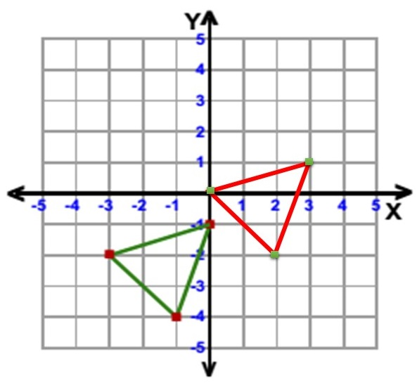 |  | 1 A Horizontal Shift  1 A Vertical Shift | (2)

GRAND TOTAL: |  | 100

